TRADE THE SLOPE SYSTEM
BY EMATRADER

POSTED ON
WWW.FOREXFACTORY.COM

Chart set-up

Step 1:
Open 6 charts of any currency pair you would like to trade.
- Daily chart
- H4 chart
- H1 chart
- 30M chart
- 15M chart
- 5M chart

If you are trading USD/JPY your charts should look like this now.
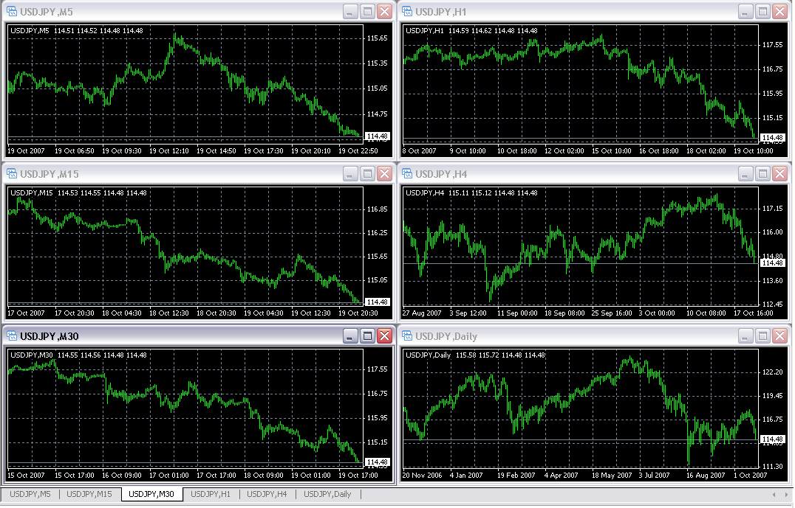

Step 2:
Add slope direction indicator to all charts.
Add this to 15M chart.
- Pivot point indicator
- Support and resistance levels
Now your charts should look like this for USD/JPY

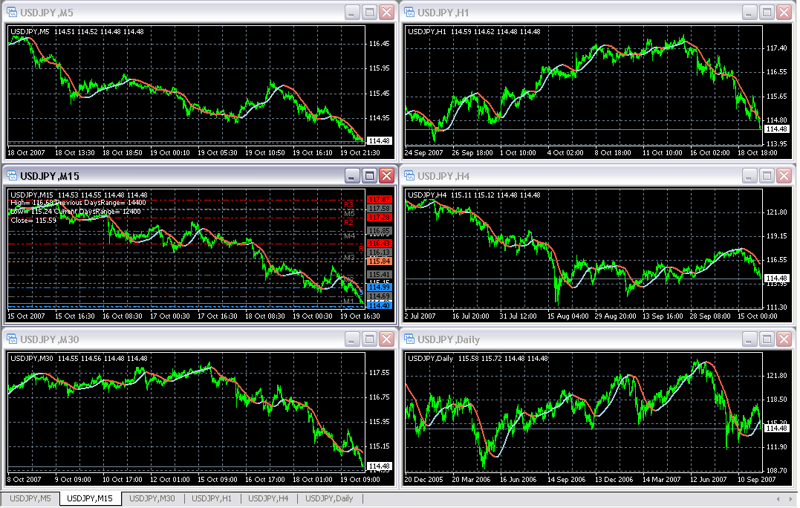

How to trade this system
I’ll show you exactly how I trade. I have a day job. So I open all my trade just after 5PM EST time. Lets says, for example, today is July 12th 2007 and its 5PM EST. I would like to trade USD/JPY today only. What I would do, I’ll open one position will be open for few days and I’ll to inter day trading on the same pair to catch small moves.
Okay, here are the steps that I would do.
Step 1: Look at the daily chart.
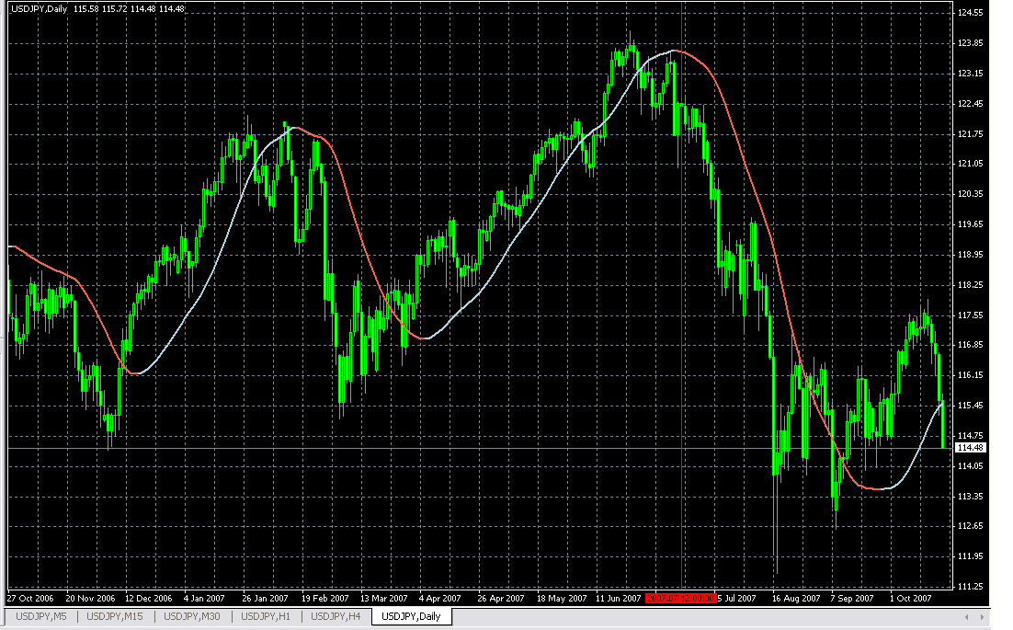
What I see on this chart is that slope on the daily chart has changed from blue to orange indicating downtrend.
Now what we do? Well, we will try to find the best entry point for our short position, which will be open for many days.

Step 2:
H4 Chart also indicates at 5PM EST that the trend is down.
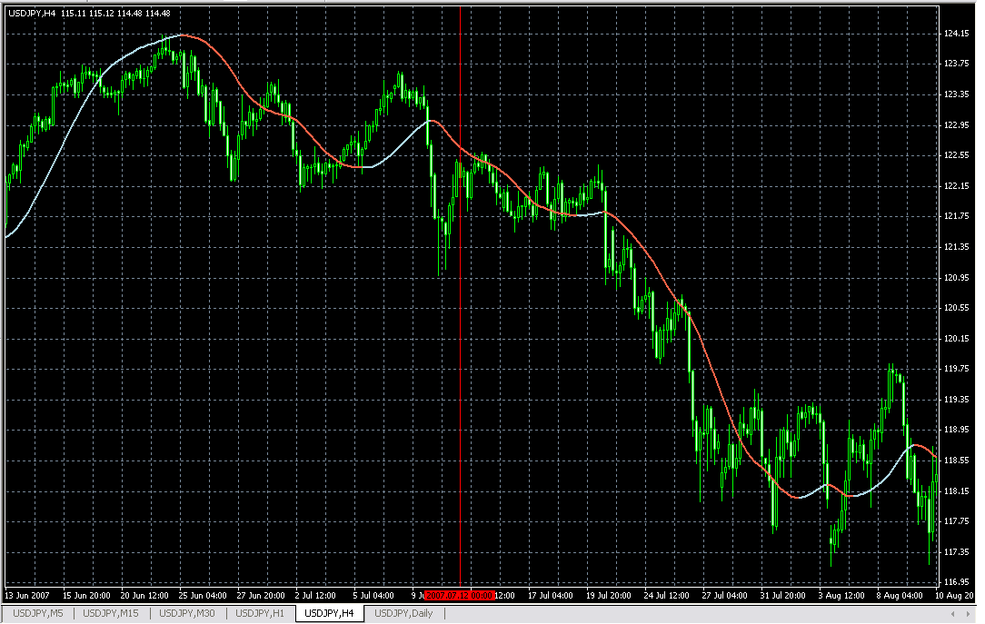

H1 Chart slope is positive at 5PM EST time.
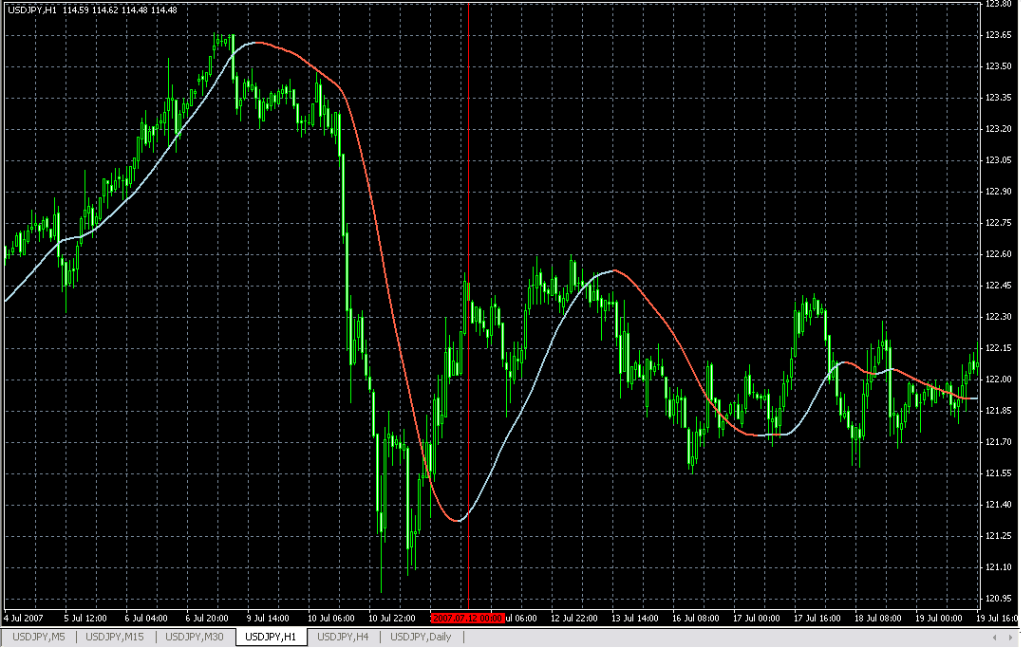
M30 Slope is positive at 5PM EST.
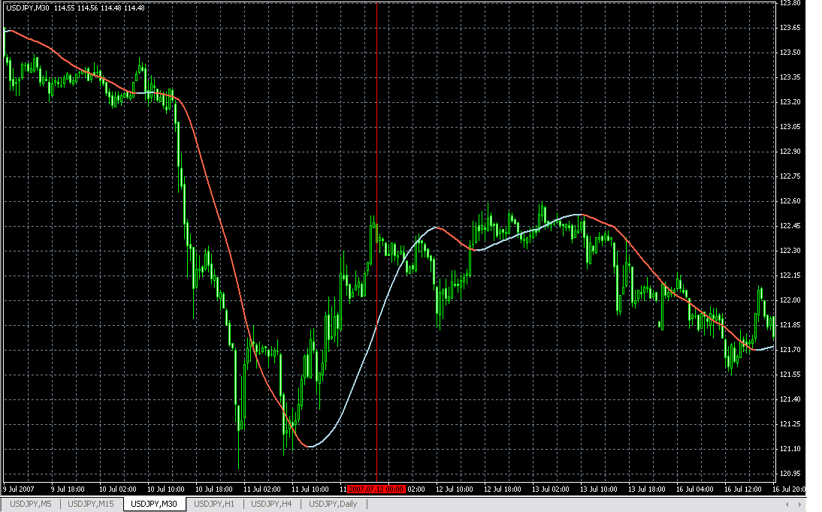
Since 30M and H1 have positive slope it is not the best time to enter in the trade. We will wait until both these charts will have negative slope alone with H4 and daily.

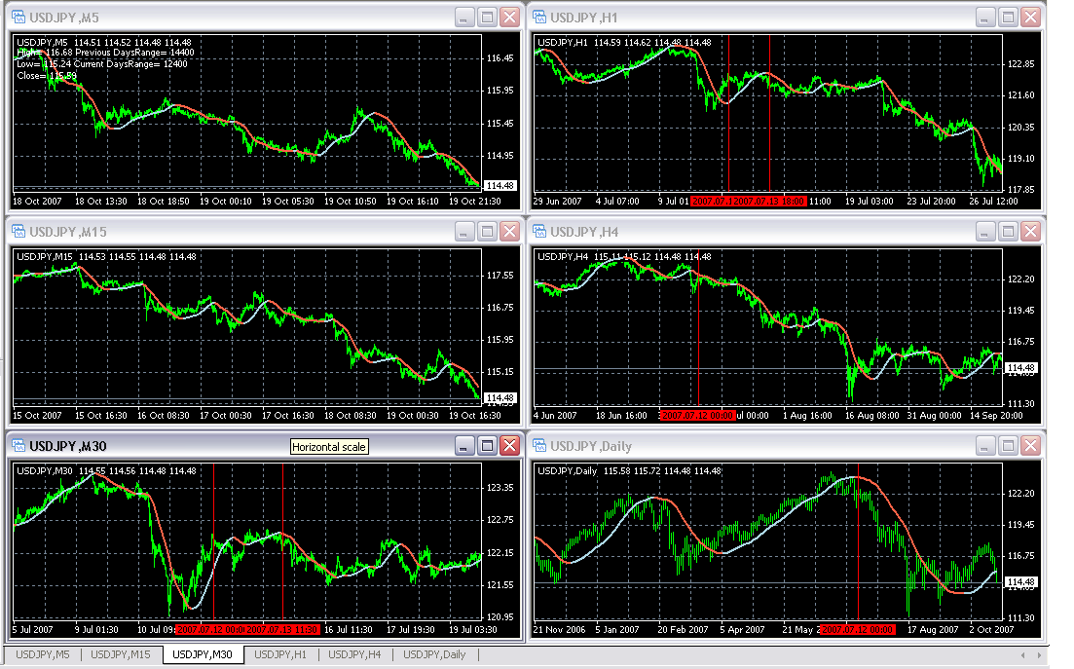
So here we see that 2007-07-13 at 18:00 GMT the slope changed the direction on H1 chart.
On 2007-07-13 at 18:00 GMT the slope was already negative on 30M chart.
Hence, I go short on USD/JPY with 100PIP stop loss without any profit target! But just in case I place my T/P at 200 PIPS. However, it is not likely that USD/JPY will move 200 PIPS in a day. I will check my trade status every day at 5PM EST and move my SL/TP accordingly.
- Short at 122.02 with 100 PIPS stop loss (Price never went above 122.37)
- Exit on 114.06
- Total profit +796 PIPS
- When to exit? Look at the chart below.

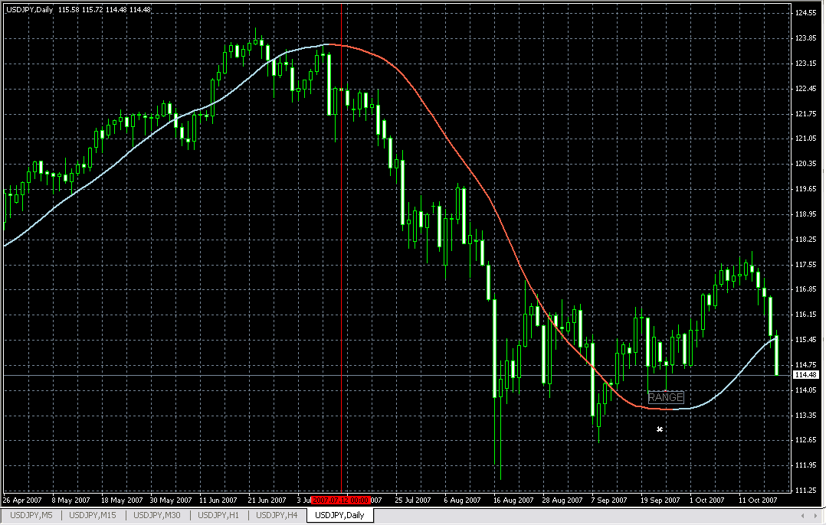
See the slope is almost going at 0 degree (moving in range). When you see the slope is changing direction toward 0 that’s the time to exit the trade. (Daily chart)
Trade closed on 2007-09-20
+796 PIPS in just over two month period. From one trade and one pair.
On My next document I’ll show you how to make pips from small moves.
Try it on a demo account. Let me know your comments and results.

Have a nice day!

